

**  **

**17wh1a1208 17wh1a1229 17wh1a1256**

**J.Mamatha K.Anupriya J.Indraja**

**Tools and Technologies**

* **Python 3.6**
* **Pycharm**
* **Pygame**

**Conclusion and Future Scope**

This project gives us more thrilling and fun.The experience of working in team and integration of modules develop

Independently, with just requirement specifications, is a very important achievement for the Snake game team. It helps us in many sectors like – planning, designing, developing, managing, programming skill, socket programming and so on.

**TEAM**

**13**

**SNAKE GAME**

**BVRIT HYDERABAD**

**College of Engineering for Women**

**Department of Information Technology**

**Hobby Project – III B.Tech I Sem - Academic Year 2019-20**

**Team Members**

**Abstract**

This project aims to bring the fun and simplicity of snake game with some new features. It will include computer controlled intelligent opponents whose aim will be to challenge the human players. This project explores a new dimension in the traditional snake game to make it more interesting and challenging. The simplicity of this game makes it an ideal candidate for a minor project .It is simple single player platform game, where the snake has to collect all the food in order to the position of the food. The aim of the game is to collect the dots(food). When it encounters a piece of food, the snake grows longer and we gain a Points .If it hits into itself, snake will die.

**Web 2.0 technologies made users to spend more time on the Internet to search for answers about various questions.**

**Game Screenshots**

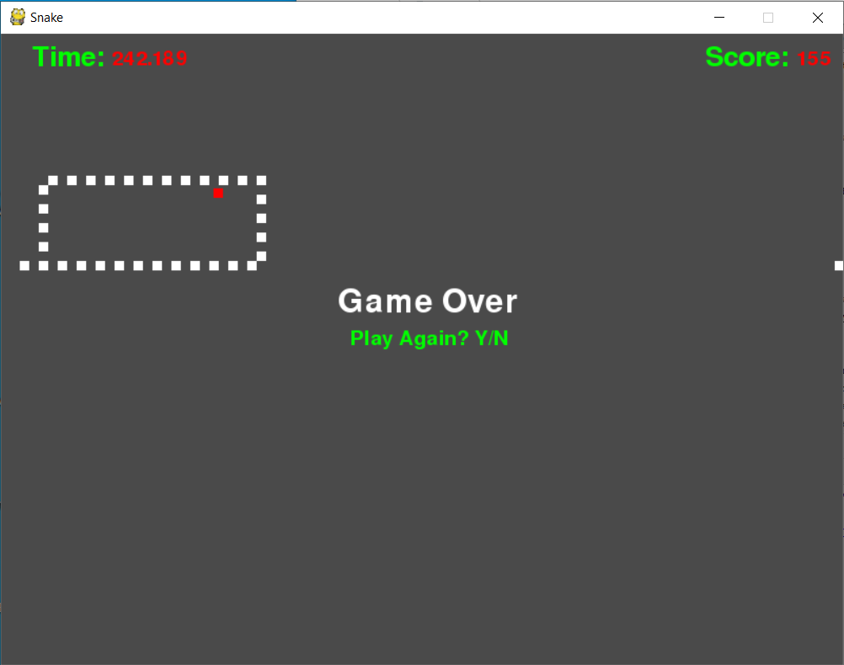

**Modules**

* Template Designing
* Snake Movement
* Score Increment
* Dot Functionality
* Win Functionality
* Loss Functionality